Young Researchers Wanted:
Assistive Technology, e-Accessibility, Technology & Ageing

** please share via your channels **

Are you a young researcher writing your bachelor / master / PhD thesis or doing new research in Assistive Technology, e-Accessibility, Technology & Ageing or related topics?

Please contribute your work to ICCHP ONLINE Young Researcher´s Consortium 2020.
For further info, visit https://www.icchp.org/next-gen-20

Accepted young researchers will:
- present their work during a 2-day pre-conference of the ICCHP (September 7-8, 2020)
- discuss the current state and future steps of their research with peers and experts
- learn about research in this field from experienced researchers
- participate for free in the ICCHP events (see note)
- meet new people doing research and have fun!

* Please note:
- If a YRC applicant is successful and also has a paper accepted to the main ICCHP conference, they will need to pay for a full conference registration.
- Submission of an accepted ICCHP conference paper as a YRC submission is not permitted.
- All applicants will receive detailed feedback on their application.

Application deadline June 22nd, 2020

#icchp2020 #YoungResearchers #AssistiveTechnology #a11y

The ICCHP Young Researcher Consortium is co-organised by chairs from:
JKU Linz, Austria

fhg health university of applied sciences tyrol, Austria | 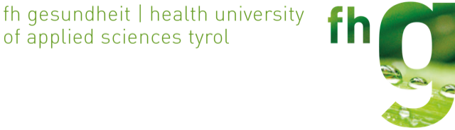
Ryerson University, Canada

